**Invasive Plant News Clips**

**October, 2015**

**********************************************************

<http://phys.org/news/2015-10-invasive-blossoming.html>

**Trade in invasive plants is blossoming**

Phys.org, October 3, 2015 by Peter Rüegg

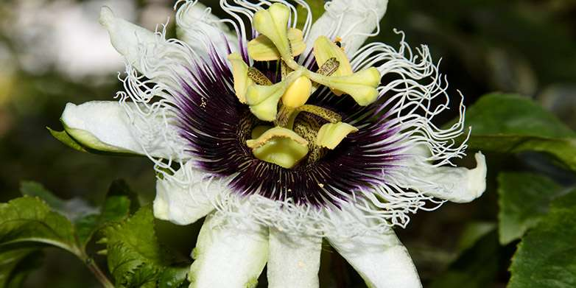

Pretty invasive: *Passiflora edulis*, or passionfruit, is an attractive ornamental plant, native to Brazil, Paraguay and Argentina. Credit: Leonardo Ré Jorge / Wikimedia Commons

**********************************************************

<http://www.theatlantic.com/science/archive/2015/10/ebay-invasive-plants/408892/>

**How eBay Could Be Messing Up the World’s Ecosystems**

Researchers have discovered a potentially damaging, unregulated online trade in invasive plants.

Amy X. Wang, The Atlantic (DC), Oct 4, 2015

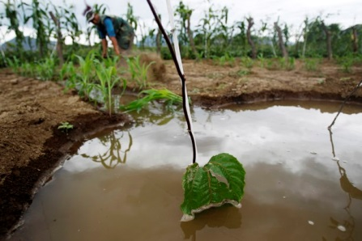

A lone passionfruit leaf Enrique Castro-Mendivil / Reuters

**********************************************************

<http://www.natureworldnews.com/articles/17253/20151004/ebay-aiding-invasive-plants-worse-thought.htm>

**eBay Aiding Invasive Plants? It's Worse Than We Thought**

By [Brian Stallard](http://www.natureworldnews.com/reporters/brian-stallard), Nature World News, Oct 04, 2015 09:10 PM EDT

**********************************************************

<http://www.futurity.org/invasive-plants-ebay-1018652-2/>

**Invasive plants can roam the world via eBay**

Futurity Research News, Posted by Peter Rüegg-ETH Zurich on October 5, 2015

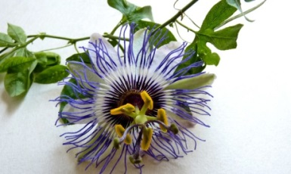

* + [*googleplus*Google+](https://plus.google.com/share?url=http%3A%2F%2Fwww.futurity.org%2Finvasive-plants-ebay-1018652-2%2F)
  + [*linkedin*LinkedIn](http://www.linkedin.com/shareArticle?mini=true&url=http%3A%2F%2Fwww.futurity.org%2Finvasive-plants-ebay-1018652-2%2F&title=Invasive+plants+can+roam+the+world+via+eBay&source=futurity.org)
  + [*pinterest*Pinterest](http://pinterest.com/pin/create/button/?url=http%3A%2F%2Fwww.futurity.org%2Finvasive-plants-ebay-1018652-2%2F&media=http://www.futurity.org/wp/wp-content/uploads/2015/10/passionflower_1170.jpg&description=Invasive+plants+can+roam+the+world+via+eBay)
  + [*reddit*Reddit](http://www.reddit.com/submit?url=http%3A%2F%2Fwww.futurity.org%2Finvasive-plants-ebay-1018652-2%2F&title=Invasive+plants+can+roam+the+world+via+eBay)
  + [Stumbleupon](http://www.stumbleupon.com/submit?url=http%3A%2F%2Fwww.futurity.org%2Finvasive-plants-ebay-1018652-2%2F&title=Invasive+plants+can+roam+the+world+via+eBay)
  + [*mail*Email](http://www.futurity.org/invasive-plants-ebay-1018652-2/#share-via-email-modal)
  + [[Printer Icon](javascript:window.print();)Print](javascript:window.print();)

*Passiflora edulis*, or passionfruit. (Credit: [Ze'ev Barkan/Flickr](https://flic.kr/p/9UxyNE))

**********************************************************

<http://www.minnesotafarmguide.com/news/crop/october-weed-of-the-month-buckthorn/article_a6b20c6a-6944-11e5-ab8d-07f1bb041069.html>

**October Weed of the Month: Buckthorn**

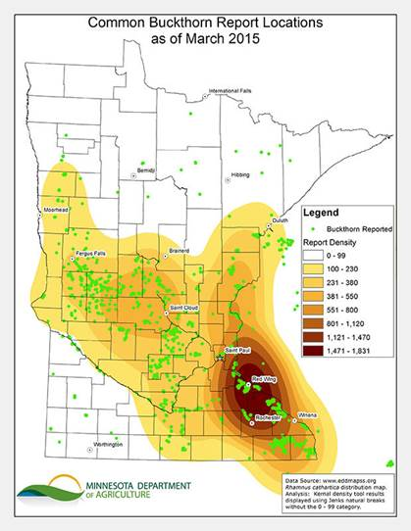

Emilie Justen, Minnesota Department of Agriculture for MN Farm Guide, 100515

**********************************************************

<http://www.zmescience.com/science/biology/invasive-plants-ebay-05102015/>

**We’re buying invasive plants on Ebay, and this is bad news**

ZME Science, October 5, 2015October 5, 2015

**********************************************************

<http://www.pressherald.com/2015/10/07/portland-citizens-group-proposes-strong-pesticide-ban/>

**Portland citizens’ group proposes broad pesticide ban**

BY KELLEY BOUCHARD, Press Herald (ME), 100715 at 4:00 AM

**********************************************************

<http://www.lakecountrynow.com/news/lakecountryreporter/hartland-marsh-cleanup-effort-continues-but-future-uncertain-b99591270z1-330866151.html>

**Hartland Marsh cleanup effort continues, but future uncertain**

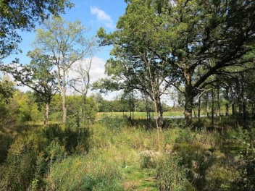

**A detention pond (back right) is visible Sept. 29 through trees in the Hartland Marsh. Previously invasive species had blocked the pond from view, but a sustained clearing effort has reduced the invasive species in the marsh.**

By Steven Martinez, Lake Country Now (WI), Oct. 6, 2015

**********************************************************

<http://discover.umn.edu/news/environment/new-grants-will-help-minnesota-fight-invasive-pests-and-plants>

**New grants will help Minnesota fight invasive pests and plants**

University of Minnesota, October 8, 2015

**********************************************************

<http://www.baltimoresun.com/news/maryland/baltimore-county/towson/ph-tt-goats-1014-20151012-story.html>

**Goats go green by eating invasive plants and vines in Towson area**

Larry Perl, Baltimore Sun (MD), October 12, 2015

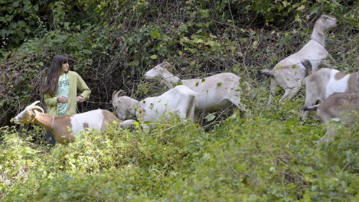

Sophie Nasrallah, 17, a St. Paul's School for Girls senior from Lutherville, works with goats to clear porcelain vine, an invasive species, from an area of the school's campus in Brooklandville on Sunday, Oct. 11, 2015. Nasrallah brought the goats to campus from Harmony Church Farm in Darlington as part of a three-year project under the school's Scholars Program.

**********************************************************

<https://wabi.tv/2015/10/13/biologists-invasive-plant-at-maine-new-hampshire-border/>

**Biologists: Invasive Plant At Maine, New Hampshire Border**

WABI (ME), Oct 13, 20154:17 PM EST

**********************************************************

<http://www.goshennews.com/news/lifestyles/invasive-plants-are-taking-over-the-woodlands/article_afe0bc4b-012f-5678-b9f1-0847584b56ea.html>

Invasive plants are taking over the woodlands

By JEFF BURBRINK, Goshen News (IN), Posted: Tuesday, October 13, 2015 5:30 am

[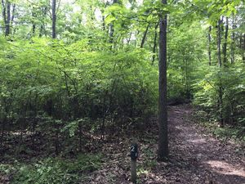](http://www.goshennews.com/news/lifestyles/invasive-plants-are-taking-over-the-woodlands/article_afe0bc4b-012f-5678-b9f1-0847584b56ea.html?mode=image&photo=0)

Burning Bush (euonymus alata), a common landscaping plant, took over acres of this woodland in northwestern Elkhart County. Unless control measures are taken, timber species such as oak or maple will not be able to reforest this area. PHOTO CONTRIBUTED.

**********************************************************

<http://www.sanjuanjournal.com/news/332262452.html>

**Watch out for toxic, invasive plant the Spurge Laurel**

The Journal of the San Juan Islands (WA), Oct 13, 2015 at 8:00AM

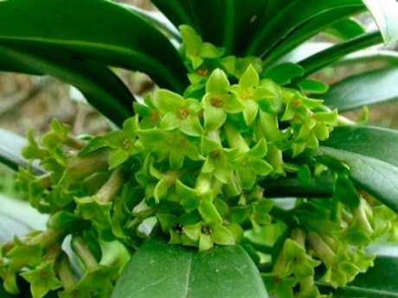

Spurge laurel in late winter *— image credit: Contributed Photo*

**********************************************************

<http://www.burnabynow.com/news/burnaby-getting-the-upper-hand-in-invasive-plant-battle-1.2087111>

**Burnaby getting the upper hand in invasive plant battle**

Jeremy Deutsch, Burnaby Now (BC, Canada), October 15, 2015 03:29 PM

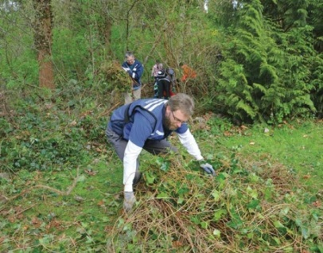

The City of Burnaby will continue to battle invasive plants in local parks.  Photograph by File

**********************************************************

<http://www.fosters.com/article/20151013/NEWS/151019792>

**Oyster River students work to remove invasive species**

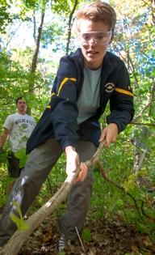

**Oyster River High School senior Nick Avery-Leaf  helps restore native plants at Beards Creek in Durham last week by pulling out invasive plants. Photo by Shawn St.Hilaire/Fosters.com**

By Brian Early, Foster’s Democrat (NH), Oct. 13, 2015 at 5:18 PM

DURHAM, NH —

**********************************************************

<http://www.syracuse.com/living/index.ssf/2015/10/questions_on_invasive_plants_in_ny_state_why_are_some_on_the_list.html>

**Questions on invasive plants in NY state: Why are some on the list?**

By [Carol T. Bradford, Syracuse.com](http://connect.syracuse.com/user/cbradford/posts.html) (NY), The Post-StandardOctober 14, 2015 at 3:38 PM

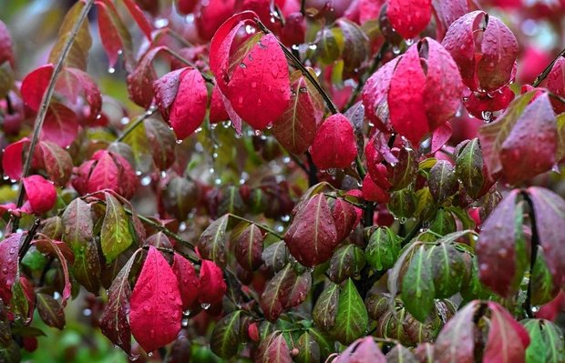

Leaves on a burning bush tree turning red in the Inner Harbor in Syracuse

*(Michael Greenlar | mgreenlar@syracuse.com)*

**********************************************************

<http://www.theprairiestar.com/news/crop/three-invasive-plants-added-to-noxious-weed-list/article_4137c8f2-7425-11e5-86e0-875f2c745d25.html>

**Three invasive plants added to noxious weed list**

Sarah Brown, The Prairie Star (MT), October 16, 2015 11:45 am

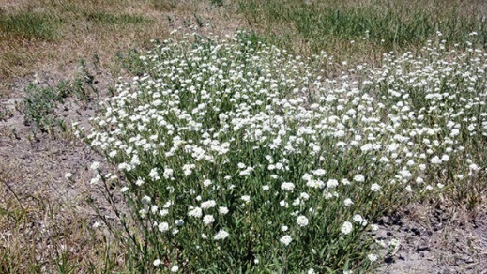

Hoary alyssum is a member of the mustard family and it is toxic to horses both on the stem and cured in hay. It thrives in drought conditions and it is prolific in western Montana.  A key feature is the rabbit ear appearance of each petal and the short, star-shaped hairs covering the entire plant. Photos by Becky Kington, Montana Weed Control Association executive director

2015-10-16T11:45:00Z Three invasive plants added to noxious weed listSarah Brown, The Prairie Star The Prairie Star

**********************************************************

<http://www.zanesvilletimesrecorder.com/story/news/local/2015/10/17/invasive-species/73888614/>

**What’s up with these invasive species?**

Nicole Hafer, Times Recorder (OH), 5:20 p.m. EDT October 17, 2015

**********************************************************

<https://www.youtube.com/watch?v=o3Nnxrw8bXY>

**City of Cape Town on a drive to clear invasive plant species**

[SABC Digital News](https://www.youtube.com/channel/UC8yH-uI81UUtEMDsowQyx1g) (South Africa), Published on Oct 18, 2015

**********************************************************

<http://www.scientificamerican.com/article/invasive-plants-are-moving-from-the-northern-hemisphere-south/>

**Invasive Plants Are Moving from the Northern Hemisphere South**

**Intrusive plants tend to originate in the Northern Hemisphere**

By Mark Fischetti, Scientific American, Oct 20, 2015

**********************************************************

<http://www.theforecaster.net/falmouth-spends-less-than-planned-to-stem-invasive-plants/>

**Falmouth spends less than planned to stem invasive plants**

By Colin Ellis, The Forecaster (ME), October 20, 2015

FALMOUTH, ME —

**********************************************************

<http://pickenssentinel.com/news/1285/clemson-students-publish-guide-to-states-invasive-plants>

**Clemson students publish guide to state’s invasive plants**

Pickens Sentinel (SC), First Posted: 3:43 pm - October 19th, 2015

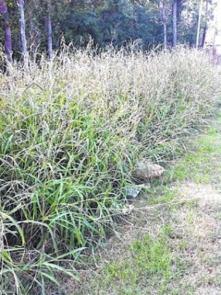

Itchgrass is one of the invasive plants included in the guide.   
*Photo courtesy of Clemson University*

**********************************************************

<http://greatlakesecho.org/2015/10/21/artist-prints-native-plants-on-invasive-species/>

**Artist prints native plants on invasive species**

By: Kayla Smith | Great Lakes Echo (MI), October 21, 2015

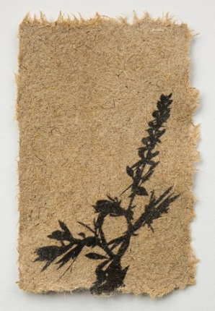

*A shadow of cream wild indigo printed on paper made from the invasive species, Phragmites australis.*

*Image: Jane Kramer*

**********************************************************

<http://www.vicnews.com/news/337985281.html>

**Group dedicated to stopping invasive plants**

by [Kendra Wong, Victoria News](http://www.vicnews.com/staff_profiles/300821481.html) (Canada), posted Oct 28, 2015 at 9:00 AM

**********************************************************

<http://www.wkbw.com/am-buffalo/managing-invasive-plants>

**Managing Invasive Plants**

Frank Pacella, WKBW (NY), 12:23 PM, Oct 27, 2015

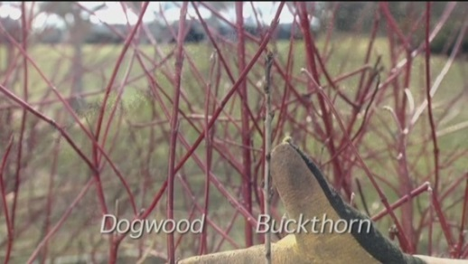

Managing Invasive Plants

BUFFALO, N.Y. (WKBW) -

**********************************************************

<http://www.telegram.com/article/20151028/NEWS/151029133>

**Lungwort find in Sturbridge raises concern about invasive plant species**

* **By Bradford L. Miner  
  Correspondent**

telegram.com

By Bradford L. Miner  
Correspondent

Posted Oct. 28, 2015 at 6:11 PM  
Updated Oct 28, 2015 at 6:13 PM

By Bradford L. Miner, Telegram.com (MA),Posted Oct. 28, 2015 at 6:11 PM

STURBRIDGE, MA –

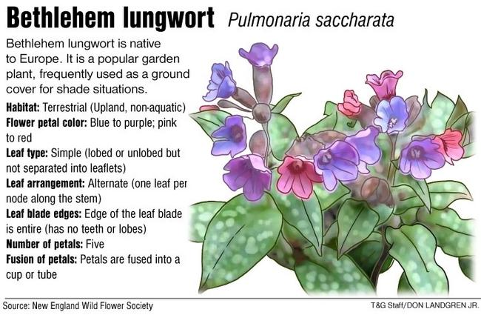

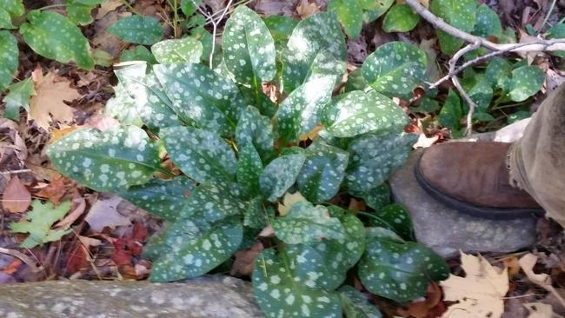

Lungwort is seen near McGilpin Road in Sturbridge, Photo/Glenn Krevosky

**********************************************************

<http://www.duluthnewstribune.com/news/3871859-public-private-partnership-benefits-duluths-parks-waterways>

**Public-private partnership benefits Duluth's parks, waterways**

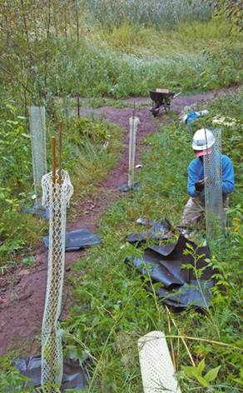

The five crew members of Community Action Duluth's Stream Corps project planted more than 2,000 trees this year, including at Chester Bowl. (Photo courtesy of Brandon Van Tassel)

Duluth Tribune (MN), Oct 29, 2015 at 7:26 pm

**********************************************************

<http://www.mankatofreepress.com/news/local_news/volunteers-clear-invasive-species-in-seven-mile-creek-project/article_457f0fec-8005-11e5-bd99-0be061b08ee8.html>

**Volunteers clear invasive species in Seven Mile Creek project**

By Nancy Madsen, Mankato Free Press (MN), Oct 31, 2015

**********************************************************

<http://www.laramieboomerang.com/news/outdoors/article_9cedbd80-7f8f-11e5-93de-5b6d86fd3529.html>

**Plan aimed at controlling invasive plants**

**By EVE NEWMAN, Laramie Boomerang (WY),** Posted: Saturday, October 31, 2015 5:00 am

[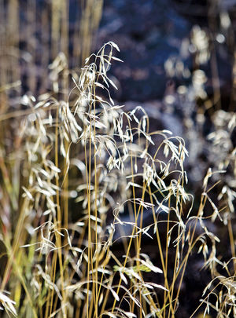](http://www.laramieboomerang.com/news/outdoors/article_9cedbd80-7f8f-11e5-93de-5b6d86fd3529.html?mode=image&photo=0)

JEREMY MARTIN

**********************************************************

<http://us2.campaign-archive1.com/?u=38f6cb875c2fe364214288c52&id=c557bf334a>

**TechLine Invasive Plant News**

Fall 2015 Issue

|  |  |
| --- | --- |
| |  | | --- | |  | |

**********************************************************

<http://techlinenews.com/photo-contest/>

**TechLine Invasive Plant News**

Invasive Plant Management Photo Contest

**********************************************************