End of Research Study

Analysis of the Efficacy of Spraying Versus Manual Removal of Invasive Oplismenus undulatifolius (wavyleaf basketgrass) in Little Paint Branch Park

Submitted by:
Nathan Kurtanich

Supervised by:
Marc Imlay and Michael Ellis

Abstract:

Oplismenus undulatifolius is an invasive grass that has been present in the state of Maryland for nearly 20 years, and over the years it has become an ever worsening problem. This study was conducted in order to determine whether manual removal or herbicide spraying is the more effective method of managing this plant.
The experiment was set up with two plots that were 15.2 x 15.2 m², plus a third plot that was 9.1 x 9.1 m² to serve as an additional data source for the study. One of the 15.2 x 15.2 m² plots was designated for the manual removal (by hand pulling), and the other two plots were designated for spray herbicide treatment. Individual grass specimens inside each plot were counted before the treatment. O. undulatifolius that remained in the plots after the treatment were counted weekly until the conclusion of the study. Number of person hours were then compared as the time it took for each treatment, which was the basis of this study. From there, ideas for future studies were proposed.
Based on this study, herbicide spraying was more effective than manual pulling at reducing stands of O. undulatifolius. Manual removal management requires a significantly higher number of person hours in order to be an effective treatment. Also, even if all O. undulatifolius specimens are manually removed, new individuals will continue to appear as a result of the seed bank or from regenerating stolons that were only partially removed.

Introduction:
As more invasive plants begin to move into areas non-native to them, their ability to grow and propagate increases substantially. Considerable amounts of time and money were spent to control these organisms only to find that some are completely ineffective against the target organism. Biological invasions are considered to be a major threat to biodiversity (Lindenmayer et al. 2015). As a result, invasive species management is often justified through its contribution to biodiversity conservation goals (Lindenmayer et al. 2015). These organisms are able to adapt to better survive. Due to the absence of natural herbivores, invasive species will be able to propagate successfully in their non-native habitat (Blossey et al. 1995). For this reason, management efforts were needed to examine for target species.
In the case of Oplismenus undulatifolius, or wavyleaf basketgrass (hereafter, WLBG), current management efforts being used to treat the species were herbicide spray or manual removal. However, due to restrictions with park department funding as well as the threat of non-target toxicity from herbicide use, the efficacy of these two treatment methods were tested in a study to compare and contrast them in order to determine which one was most efficient. Manual removal was hypothesized to be a more effective removal method than herbicide spray.
WLBG is a relatively new plant to the United States, and its total threat is still unknown (Imlay pers. comm.). It was first discovered growing in the United States in 1996 in two different areas located northwest of Baltimore, Maryland (Beauchamp et al. 2013; Imlay 2008; Kyde et al. 2008). One of those sites was Patapsco Valley State Park (Imlay 2008; Westbrooks et al. 2009). WLBG has been found in six counties in Maryland and seven counties in Virginia (Beauchamp et al. 2013). Shortly after this, WLBG was identified and declared a noxious weed. A noxious weed is defined as any plant or plant product that can directly or indirectly injure or cause damage to crops, livestock, poultry, or other interests of agriculture, irrigation, navigation, the natural resources of the United States, the public health, or the environment (Tasker 2010). There are many ways to treat WLBG including manual removal techniques as well as spray herbicide treatment. However, they both are used as techniques for earlier detection and rapid response. This means that when the invasion is treated, it needs to be addressed early on and quickly.

Materials and Methods:
In order to test this hypothesis, three test plots were set up in Little Paint Branch Park in Beltsville, MD. One of the plots had an area of 15.2 x 15.2 m². This plot contained isolated WLBG and this plot was treated by use of manual removal methods. The second plot was 15.2 x 15.2 m² in area. This plot was treated with herbicide spray on isolated grass specimens. The third plot covered an area of 9.1 x 9.1 m² and contained monocultures of WLBG. This third plot had the greatest density of WLBG and was also sprayed with herbicide.
Prior to the treatment of each site, the sites were measured out for their specific dimensions with flags to indicate where the perimeter of the plot was located. For the manual removal plot, the manual removal was accomplished with the help of eight volunteers. The herbicide plots were treated with Round-Up Pro, a glyphosate based herbicide. The treatment of the plots consisted of spraying an herbicide that had a concentration of 31.3 ml/liter. At this proportion, the herbicide solution used to treat the plots was a 1.5% glyphosate per volume solution.
For the data collection of this study, counts of all of the individual WLBG were conducted within each of the three plots prior to the beginning of the study. After the initial treatment of each plot, follow up counts of each plot were conducted. This involved the author, Nathan Kurtanich, walking along one of the edges of the plot in a winding style gradually working towards the opposite edge of the plot. As the author walked through the plot, he surveyed a two meter wide path in front of him on each pass. Every individual WLBG in the plot was counted on each sweeping pass being careful not to count any WLBG twice.

Results:
By the end of the study, data was collected on six different dates per plot. Initial data was collected one or two days before the treatment was performed. Post-treatment data was collected five times for each plot. Approximately one week was allowed in between each data collection, which is shown in the chart below.

Table 1: Data table displaying the counts of Oplismenus undulatifolius that were collected from the three test plots on each specific collection day.
Date of data collection | Plot #1 | Plot #2 | Plot #3 | Number of counts since initial treatment
7/29/2015 | 948 | 1,564 | 1,612 | 0
8/7/2015 | 109 | 37 | 19 | 1
8/14/2015 | 203 | 32 | 7 | 2
8/19/2015 | 231 | 13 | 2 | 3
9/2/2015 | 236 | 25 | 0 | 4
9/9/2015 | 240 | 27 | 1 | 5

In addition to the weekly count from each plot, measurements of the bare land area within each plot were taken to see how much was present. At the end of the study, a follow up measurement was done to see what the increase in bare land area was after being treated with herbicide. These measurements were only taken in plots #2 and #3 which were treated with herbicide. Since these measurements were taken to measure the damage to non-target plants by herbicide, measurements from plot #1 were not taken since this plot was treated by manual removal. This was because there would be little to no damage done to native plants that was worth noting in this test plot. If any damage was done to non-target plants, it would only be an insignificant number of grasses that one of the volunteers may have mistaken for WLBG. Additionally, the total area was compared to the bare area dimensions measured from either plot.

Figure 1: Graph representing the amount of Oplismenus undulatifolius in each of the three test plots over the course of the study.

Figure 2: This figure shows the change in bare land area between plot #2 and plot #3 at the beginning of the study, plots at the end of the study, and the total land area in each plot. These were the two plots treated with herbicide.

Figure 3: This figure shows the percentage of bare land area that is present in each plot at the end of the study.

Since the main objective of this study was to test whether herbicide spray treatment or manual removal was the more effective treatment of WLBG, counts of the number of person hours it took to treat each of the test plots were taken.

Table 2: This table shows the number of person hours that were spent treating each plot.
 | Plot #1 | Plot #2 | Plot #3
Number of people treating the site | 10 | 1 | 1
Time spent treating the site | 46 minutes  (0.8 hours) | 55 minutes  (0.9 hours) | 43 minutes  (0.7 hours)
Total person hours | 7.7 person hours | 0.9 person hours | 0.7 person hours

As you can see from Table 2, it takes more time to treat a plot of WLBG with manual removal techniques as compared to spray treatment with herbicide. In addition to the higher number of person hours, the volunteers who helped to manually remove WLBG had never seen this grass before the day of the initial treatment.

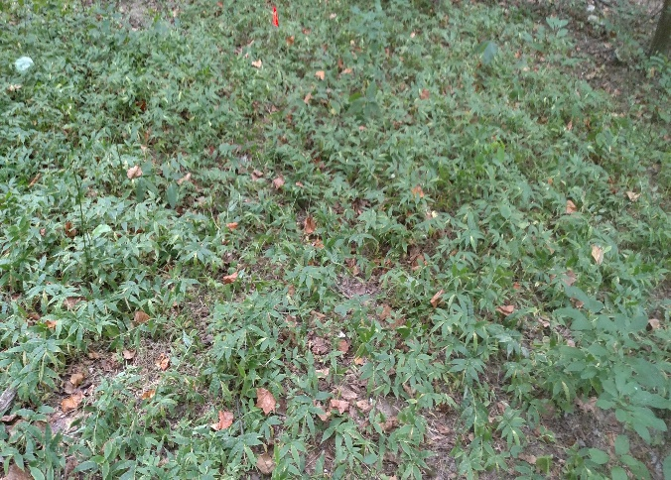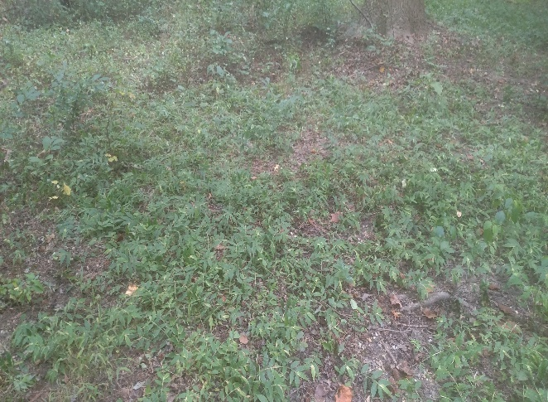
A B

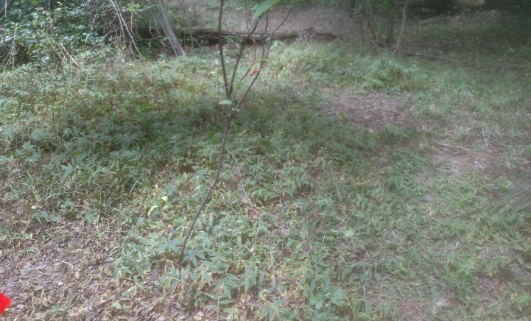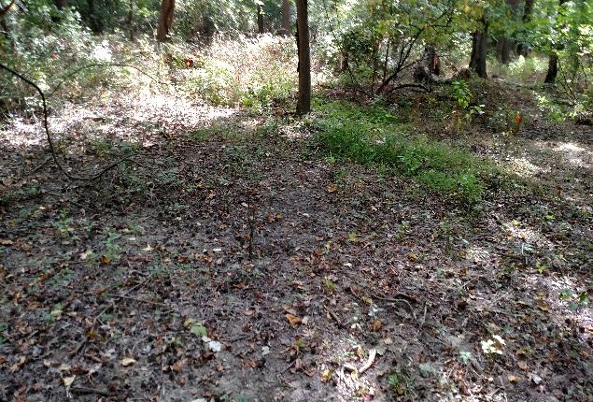
C D
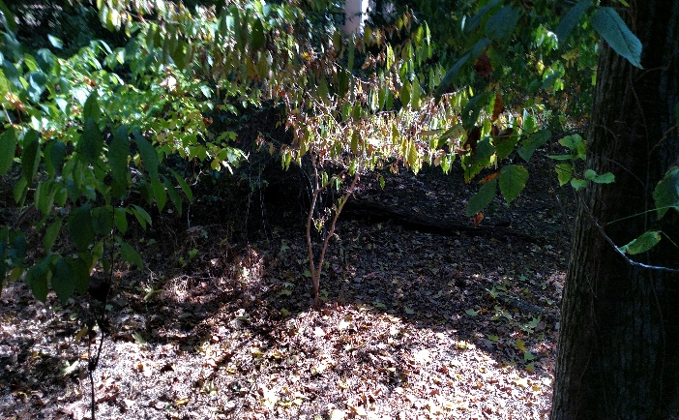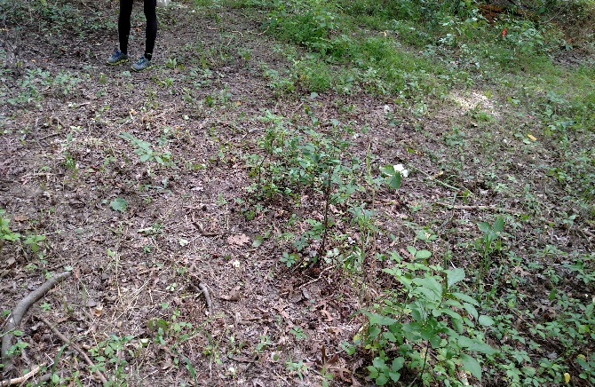
E F
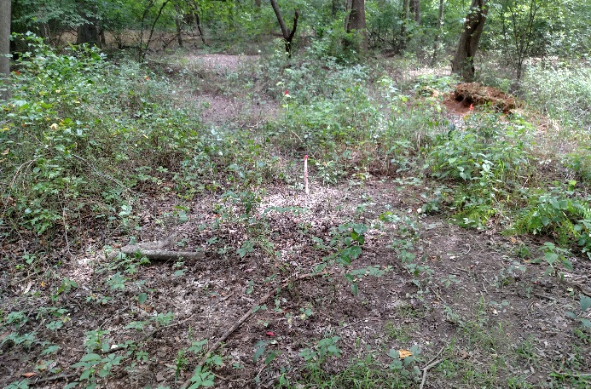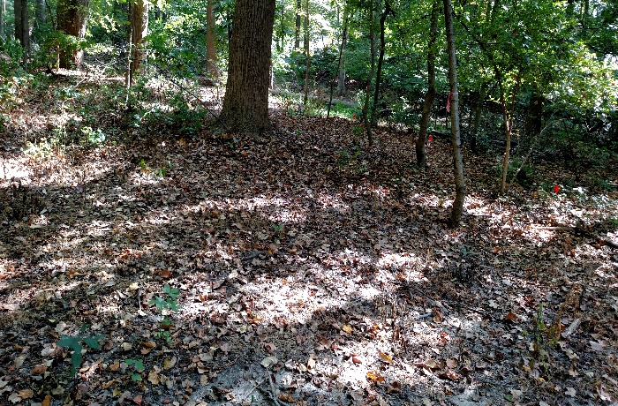
G H
Figure 4. A. Oplismenus undulatifolius in plot #2 before treatment date. B. Oplismenus undulatifolius in plot #2 one week after treatment date. C. Oplismenus undulatifolius in plot #3 before initial treatment. D. Plot #2 at the end of the study. E. Plot #3 at the end of the study. F. Plot #1 one week after initial treatment. G. Plot #1 at the end of the study. H. Plot #2 at the end of the study. All photos by Nathan Kurtanich.

Over the course of the six weeks of data collection, it was discovered that the plots treated with the glyphosate based herbicide took more than one week before showing any visible signs of dying. As the weeks went on, more and more WLBG were dying off and by the end of the data collection period there were almost no WLBG remaining in the plots.
The results from the manual removal plot were very different. After the initial treatment in the manual removal plot, there was a significant number of WLBG removed. However, there were several WLBG specimens that were missed and survived the initial treatment. As the weeks of follow up counts went on, it was noted that individual WLBG were re-sprouting within the plot. With each passing week, there was always an increase in number of WLBG compared to the week before. Upon close examination, much of the WLBG present in the plot each week were freshly sprouted WLBG. This means that WLBG was continuously sprouting either from the solons of currently existing WLBG or they were grown from seeds that sat dormant until they were noticed germinating.
Some of the non-target plants that were killed by the treatment included Parthenocissus quinquefolia and Leersia virginica. This information was noted in order to determine what species, especially any rare species, were harmed from the treatments.

Discussion:
As depicted in Table 1, periodical counts of WLBG were collected in the three plots. Plot #3 was treated with herbicide and by the conclusion of the study had almost zero WLBG alive. Even though plot #2 was also treated with herbicide, a small number of WLBG remained alive inside the plot. A small number of individual plants were missed and not treated during the initial treatment of this plot. As a result, those few WLBG didn’t die off and they were allowed to give rise to more WLBG specimens. This is why WLBG in plot #2 was not completely eliminated.
During the data collection phase of the study, measurements of the “bare land area” of the plots were taken before and after treatment. In the context of this study, the term “bare land area” was used to refer to any section of the ground within the confines of the plot that was void of any type of vegetation whether it was WLBG or something else. This measurement was chosen as a way to describe how the herbicide treatment would affect native plants. For this reason, these measurements were not taken in plot #1 (manual removal), because if any non-target plants were pulled it would be an insignificantly small number.
One of the biggest problems that occurred when treating the plots was basic human error. This means it was very easy for people to miss or overlook some WLBG present in the plot and therefore it did not get pulled or treated. This untreated WLBG was then able to propagate and make the problem even worse than before.
If the opportunity presented itself, follow up studies to the experiment would be recommended. A similar study to the one already performed would be conducted, but an additional test plot that is treated with a clethodim-based herbicide would be added. Clethodim is a grass specific herbicide. This would allow a liberal treatment and the only plants that would get killed would be the grass species. A clethodim herbicide would have been used during this study, but this herbicide is only effective in the early stages of the grasses life cycle (middle of spring - end of June) so by the time this study began, it was already too late in the season to use clethodim.
Another recommendation for follow up involves the Little Paint Branch River. Water samples from the Little Paint Branch would be collected and analyzed to see the amount of glyphosate present at various points along the tributary. Whenever herbicides are used, a serious concern is that these chemicals could have a detrimental effect on the local ecosystem. By testing the glyphosate levels in the water, a better idea of exactly how harmful glyphosate is to the environment around the study site would be known as well as how this chemical impacts other environments that are downstream from Little Paint Branch Park.
The final follow up study recommended would be to test and see if WLBG has any insects or pathogens that could possibly serve as a biological control. The problem of WLBG is rapidly getting out of hand. There will most likely be a point where this weed will overtake the natural landscape to the extent that no amount of manual removal or herbicide use will have any effect. If a biological control to attack this invasive grass can be found, then there may be a chance to completely eliminate this from our natural areas.

Conclusion:
The detrimental impacts of invasive species on our natural resources is a serious issue that needs to occupy more of our attention. Invasive plant species have been responsible for placing 35-46% of plants and animals on the endangered species list (Sheley et al. 2015). It is estimated that invasive plants in United States cost the national economy over $27 billion in 2005 (Sheley et al. 2015).
Based on the data collected in this study, the use of more herbicide for the management of WLBG is the recommended treatment method. This is based on the ability of the herbicide to effectively kill the WLBG when it is exposed and the herbicide treatment required only a small fraction of the person hours compared to the number of hours that were needed for the initial manual removal treatment.
In order to have a successful management strategy that uses manual removal techniques, a large number of dedicated volunteers will need to contribute to management efforts on a consistent basis as opposed to helping for only one day. The other issues with hand pulling management is that each treatment site would require multiple visits throughout the season in order to be sure that WLBG was completely removed. This would result in dozens of person hours to treat any given site, whereas you would only need one person hour to treat the same size plot with herbicide.
At this point in time, current management strategies for WLBG are not working as effectively as desired. Looking to the future, there is no way to realistically prepare to handle all possible outcomes in the war against invasive organisms. However, challenges posed by invasive species will become more manageable upon invasion events if alternative scenarios are studied thoroughly prior to facing the outcomes (Anderson et al. 2006). Although the use of spray herbicides to get rid of this noxious weed is currently recommend, the scientific community needs to employ adaptive management strategies and constantly reevaluate how effective our efforts are in this conflict. Hopefully, a solution to this problem can be found to help completely eliminate WLBG from our natural landscapes before it is too late.

References:
Anderson N. O., Galatowitsch S. M., & Gomez N. (2006) Selection Strategies to Reduce Invasive Potential in Introduced Plants. Euphytica 148(1/2), 203-216. doi:10.1007/s10681-006-5951-7

Beauchamp V.B., Koontz S.M., Suss C., Hawkins C., Kyde K.L., Schnase J.L. (2013) An Introduction to Oplismenus undulatifolius (Ard.) Roem. & Schult. (wavyleaf basketgrass), a Recent Invader in Mid-Atlantic Forest Understories 1,2. The Journal of the Torrey Botanical Society 391-413.

Blossey B., & Notzold R. (1995) Evolution of Increased Competitive Ability in Invasive Nonindigenous Plants: A Hypothesis. Journal of Ecology 83(5), 887.

Imlay M. (2008) Wavyleaf Basketgrass Alert. Native News: Newsletter of the Maryland Native Plant Society pp. 3-4. Retrieved from http://www.mdflora.org/Resources/Publications/NativeNews/nn_v8_n3.pdf

Imlay M. (2015) Personal communication.

Kyde K.L., Marose B.H. (2008) Wavyleaf Basketgrass in Maryland: An Early Detection Rapid Response Program in Progress An Early Detection Rapid Response Program in Progress. [Internet]. Available from: http://www.dnr.maryland.gov/wildlife/Plants_Wildlife/WLBG/pdfs/wlbg_poster011108.pdf

Lindenmayer D. B., Wood J., MacGregor C., Buckley Y. M., Dexter N., Fortescue M., Catford J. A. (2015) A Long-Term Experimental Case Study of the Ecological Effectiveness and Cost Effectiveness of Invasive Plant Management in Achieving Conservation Goals: Bitou Bush Control in Booderee National Park in Eastern Australia Plos ONE, 10(6), 1-23. doi:10.1371/journal.pone.0128482

Sheley R. L., Sheley J. L., & Smith B. S. (2015) Economic Savings from Invasive Plant Prevention. Weed Science 63(1), 296-301. doi:10.1614/WS-D-14-00004.1

Tasker A. (2011) Rapid Response: Putting Early Detection and Rapid Response (EDRR) into Practice Plant Invasions, 168.

Westbrooks R. and Imlay M. (2009) Wavyleaf Basketgrass—A New Invader of Deciduous Forests in Maryland and Virginia. Southeast Exotic Pest Plant Council Factsheet, http://www.se-eppc.org/southcarolina/WLBG.pdf

