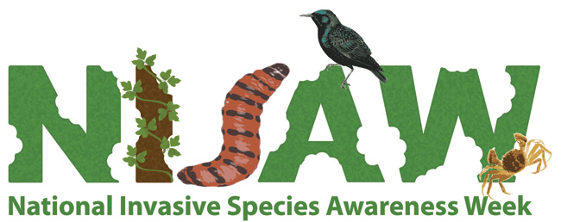
SAVE THE DATE!
NATIONAL INVASIVE SPECIES AWARENESS WEEK 2016
February 21 – 27, 2016
PARTICIPATE IN EVENTS ACROSS THE NATION to raise awareness and identify solutions to invasive species issues at local, state, tribal, regional, international and national scales. Locate an invasive species event in your state or county. Plan your own event using the NISAW Toolkit – where and when it works for you!
Plan to attend the NISAW 2016 reception and briefings on Capitol Hill!
Check www.nisaw.org for the NISAW Toolkit for planning local events and the NISAW Event Locator – as well as more specific dates, details, event schedules, complete lists of partners and further developments and other potential events in Washington, DC!.

Contacts:
Lee Van Wychen, Ph.D. Scott Cameron
National and Regional Weed Science Societies Reduce Risks from Invasive Species Lee.VanWychen@wssa.net Coalition (RRISC)
Scott.cameron@rrisc.org

Participating organizations: Association of Fish and Wildlife Agencies, Environmental Law Institute, National Environmental Coalition on Invasive Species, Nature Conservancy, Reduce Risks from Invasive Species Coalition, University of Georgia, Weed Science Society of America, Aquatic Nuisance Species Task Force, Federal Interagency Committee on Noxious and Exotic Weeds, National Invasive Species Council and many others.

