**Invasive Plant News Clips**

**February, 2016**

**********************************************************

<http://www.arkansasmatters.com/news/local-news/fayetteville-bans-18-invasive-plants>

**Fayetteville Bans 18 Invasive Plants**

**Several areas of town have been targeted for removal of the offending foliage.**

Published 2/1/2016 10:18 AM

FAYETTEVILLE, Ark. ([KNWA](http://www.nwahomepage.com/)) –

[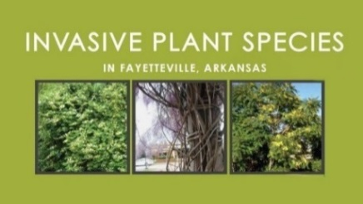](http://www.arkansasmatters.com/news/local-news/fayetteville-bans-18-invasive-plants)

**********************************************************

<http://www.shorenewstoday.com/upper_township/upper-township-committee-asks-for-ordinance-banning-invasive-plants/article_03824e5a-c9c1-11e5-8b7d-fbbc2b482803.html>

Upper Township Committee asks for ordinance banning invasive plants

Shore News Today (NJ), Tuesday, February 2, 2016 12:30 pm

[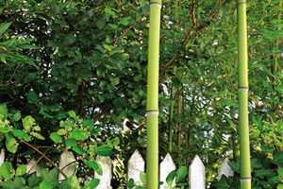](http://www.shorenewstoday.com/upper_township/upper-township-committee-asks-for-ordinance-banning-invasive-plants/article_03824e5a-c9c1-11e5-8b7d-fbbc2b482803.html?mode=image&photo=0)

**Neighbors concerned about proof in new bamboo ban**

An ordinance could be considered that would make it illegal to plant new bamboo and require residents to contain the plant on their property.

**********************************************************

<http://dlnr.hawaii.gov/hisc/news/lrbupdate/>

**Legislative Reference Bureau releases invasive species study**

Hawaii Invasive Species Council, Posted on Feb 3, 2016

**********************************************************

<http://thegardenisland.com/news/local/agency-seeks-protection-for-animals-plants/article_3450165e-2f5d-51a6-833f-8282b6383e13.html>

**Agency seeks protection for animals, plants**

**Officials look to add 49 Hawaii species to endangered list**

The Garden Island (HI), Posted: Tuesday, February 2, 2016 1:15 am

HONOLULU, HI —

[Previous](javascript:void(0);) [Next](javascript:void(0);)

[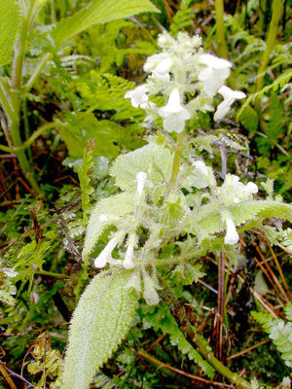](http://thegardenisland.com/news/local/agency-seeks-protection-for-animals-plants/article_3450165e-2f5d-51a6-833f-8282b6383e13.html?mode=image&photo=0)

**Contributed photo**

The phyllostegia helleri on Kauai may be added to the federal list of endangered species.

**********************************************************

<http://www.chicagotribune.com/suburbs/lake-county-news-sun/opinion/ct-lns-moran-tree-removal-0202-20160201-column.html>

**Moran: Tree lines get the ax in Washington Street road construction**

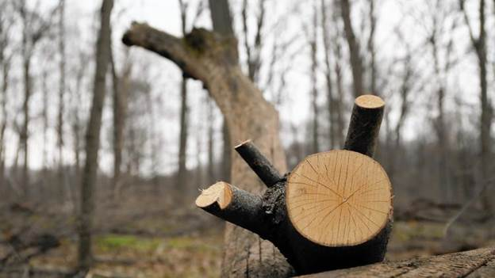

**Invasive species and road construction are both threats to trees in Lake County. (Stacey Wescott / Chicago Tribune)**

Dan Moran, Chicago Tribune (IL), 020216

**********************************************************

<http://www.agweb.com/article/internet-propels-invasive-species-naa-chris-bennett/>

**Internet Propels Invasive Species**

AgWeb (MO), February 8, 2016 05:00 AM

**********************************************************

<http://qz.com/610527/the-race-to-outsmart-invasive-plants-before-they-get-the-best-of-us/>

**The race to outsmart invasive plants before they get the best of us**

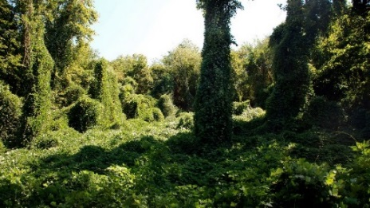

Kudzu could do big damage to American crops. (Max Wolfe/Flickr/CC-BY-2.0)

Written by Michael Edison Hayden, Quartz, February 06, 2016

**********************************************************

<http://www.blueridgenow.com/article/20160207/ARTICLES/160209951>

**Invasive plants yield unintended consequences**

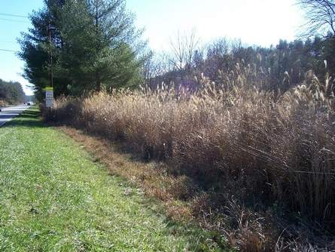

Invasive Chinese silvergrass spreads along roadsides into adjoining lands.

*Pierre Hart photo*

By Pierre Hart, BlueRidgeNow.com (NC), Published: Sunday, February 7, 2016 at 4:30 a.m.

**********************************************************

<http://www.record-eagle.com/news/local_news/battling-invasive-species-manistee-grand-traverse-conservation-districts-get-grants/article_13dec3e0-f184-535e-b50e-ad2dd440d886.html>

**Battling invasive species: Manistee, Grand Traverse conservation districts get grants**

BY CAROL THOMPSON, Record-Eagle (MI), 021216

TRAVERSE CITY, MI —

**********************************************************

<http://www.courierherald.com/news/369693341.html>

**Invasive Species Awareness Week | King County**

Enumclaw Courier Herald (WA), Feb 22, 2016 at 11:36AM

**********************************************************

<http://msue.anr.msu.edu/news/phragmites_how_is_it_an_invasive_part_3>

**Phragmites, how is it an invasive: Part 3**

**What classifies this Phragmites as invasive, why is this important, and what are the parameters for classifying an organism as invasive?**

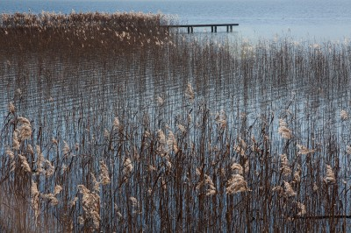

by Beth Clawson, Michigan State University Extension and Emily Cord Duthinh, Michigan Lake and Stream Leaders Institute, February 15, 2016

**********************************************************

<http://www.wdbj7.com/news/local/plants-available-at-local-nurseries-may-actually-be-bad-for-ecosystem/38133768>

**Plants available at local nurseries may actually be bad for ecosystem**

**This week is National Invasive Species Awarness Week, a week set aside to highlight the**

**needs of our delicate eco-system.**

Shayne Dwyer, WDBJ (VA), 7:08 PM EST Feb 22, 2016

ROANOKE CO., Va. -

**********************************************************

<http://msue.anr.msu.edu/news/invasive_species_week_non_native_plants_animals_a_serious_threat_bohling16>

**Invasive Species Week: Non-native plants, animals a serious threat to global, local biodiversity**

**Read this series to learn what to do to help protect Michigan and the Great Lakes.**

by Mary Bohling and Bindu Bhakta, Michigan State University Extension, 022116

**********************************************************

<http://www.nwahomepage.com/news/volunteers-committed-to-removal-of-invasive-plant-species-at-lake-fayetteville>

**Volunteers Committed To Removal Of Invasive Plant Species At Lake Fayetteville**

KNWA (AR), Published 02/22 2016 07:39AM

**********************************************************

<http://www.scotsman.com/news/environment/plant-swap-to-rid-highland-beauty-spot-of-invasive-species-1-4036641>

**Plant swap to rid Highland beauty spot of invasive species**

by Ilona Amos, The Scotsman (Scotland), 23 February 2016

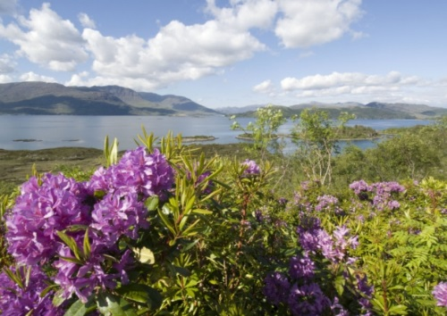

**The invasive rhododendron ponticum. Picture: NTS**

**********************************************************

<http://staugustine.com/news/2016-02-23/sallie-ohara-get-tune-dangers-invasive-plant-species>

**Sallie O'Hara: Get in tune with dangers of invasive plant species**

The St. Augustine Record (FL), Posted: February 24, 2016 - 12:43am

**********************************************************

<http://www.dailycommercial.com/columnists/article_ea1020b5-9562-5de2-91c6-b3d8ab4c55af.html>

**Invasive plants to avoid and their substitutes**

Daily Commercial (FL), Posted: Saturday, February 27, 2016 6:00 am

**********************************************************

<http://www.news-gazette.com/living/2016-02-27/sandra-mason-space-invaders.html>

**Sandra Mason: Space Invaders**

[Sandra Mason](http://www.news-gazette.com/author/sandra-mason), The News Gazette (IL), 02/27/2016 - 8:00am

[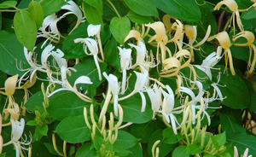](http://static.news-gazette.com/sites/all/files/imagecache/lightbox_800_600_scale/images/2016/02/26/0227_feat_jap_0.jpg)

Japanese honeysuckle

**********************************************************

<http://oakridgetoday.com/2016/02/29/tcwp-volunteers-will-remove-exotic-invasive-plants-from-oak-ridge-cedar-barren-on-march-5/>

**TCWP volunteers will remove exotic, invasive plants from Oak Ridge Cedar Barren on March 5**

By [Oak Ridge Today](http://oakridgetoday.com/author/oak-ridge-today-staff/) (TN), Posted at 8:46 am February 29, 2016

**********************************************************

<http://www.nytimes.com/2016/03/01/science/invasive-species.html?_r=0>

**Invasive Species Aren’t Always Unwanted**

By ERICA GOODE, New York Times (NY), FEB. 29, 2016

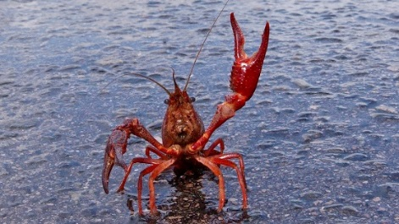

In Spain, nonnative crayfish serve as prey for migratory wetland birds. Credit Rafa Huertas/Reuters

**********************************************************