Introduction and key concepts from:
Thoughts on Sustainable ecological systems:
Permaculture from the rural farmer to the urban gardener and related subjects

PALTA 2016,
May 21, 2016

Walk more
Tinker less

Original Proposal: The future of food production and ecology will be learning ways to work with ecosystems to develop sustainable agriculture which is a functioning part of the local ecologies, not destroy them as is being done at the present time. Land trusts are ideal organizations to develop these concepts into practical applications and serve as the leaders of this transformation.

Biotech and bioengineering are engineering, not science. They do not seek to understand the world, but change it without fully understanding the consequences of what they are doing, often with disastrous consequences.

A hierarchy of mutualistic ecological relationships we need to account for when thinking about landscapes:

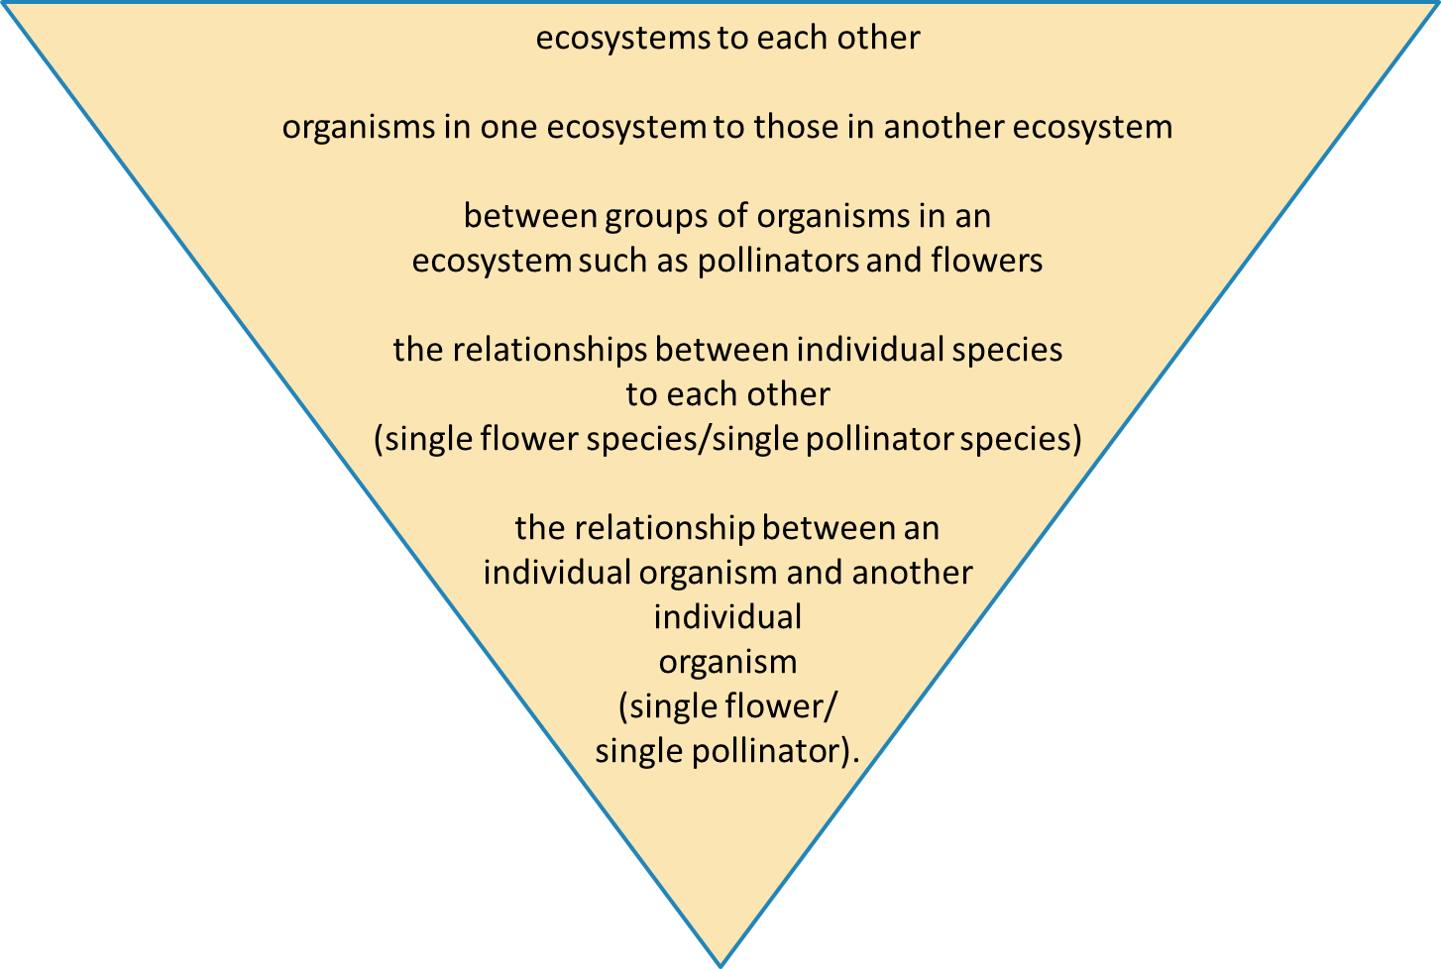
One of the most important questions we need to answer is the difference between a native plant and a non-native plant.

Hybridizing a native plant with another native plant creates a non-native plant.

In Invasive Plant Ecology we have the Enemy Release Hypothesis.
In part, this states that an overwhelming number of native organisms cannot use non-native plants because they did not coevolve together.

Therefore, hybridizing a native plant with another native or especially a non-native creates a non-native plant of little or no ecological utility.

By changing the gene structure of a native plant through hybridizing with a non-native in hopes of “improving” the plant or making it resistant to (introduced) diseases or pests is doomed to be an ecological failure because few if any native organisms using the native plant will be adapted or adapt to use this hybrid due the unnaturally rapid changes in the physical and chemical properties of the plant.

In other words, we do not want to create non-native plants because it destroys their ecological utility as a food source for pollinators, ceases to be a food for larvae, changes their utility for decomposers and organisms that depend on this relationship, may destroy their functionality with soil fungi and a long list of other negative impacts.

Only generalist organisms, such as various insects, mammals and birds, can utilize non-native plants and other non-native organisms.

This means the extinction of many native specialist organisms and their interrelationships with other organisms.

Wild organisms, such as pollinators, within a species and between species have genetic variability in size, shape, maturity rates, growth rates, food preferences, habitat preferences and their ability to use different individuals within the same species of a plant population.

The differences may appear small to us, but can be large in the local ecology.

For mutualistic relationships to thrive such as pollinators and flowering plants, native flowering plants need heterogeneity within the species to match the same heterogeneity within a pollinator species and among species using it.

These photos are examples of color heterogeneity within a wild azalea species, Rhododendron periclymenoides, found within 100 yards of each other near home on May 19, 2016:
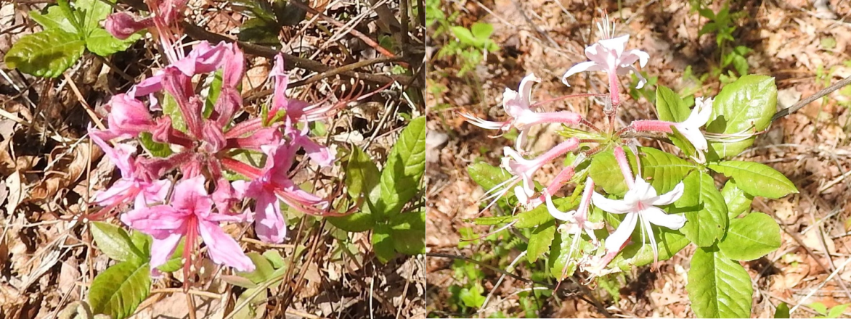

For example:
A large diverse meadow of flowers benefits from a large diverse group of pollinators in that meadow.

Another example:
Last fall I watched a monarch butterfly (Danaus plexippus) migration on Blue Mountain near home.
Of the dozens of butterflies I watched, one preferred the white flowered Boneset (Eupatorium perfoliatum) while all the others preferred yellow flowered Goldenrod (Solidago) species.

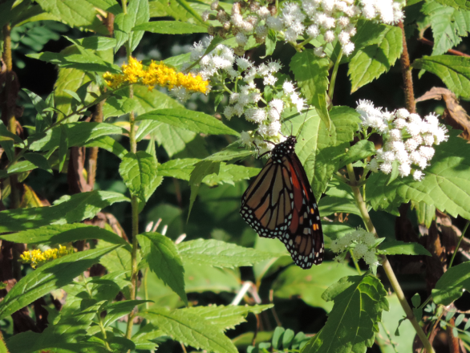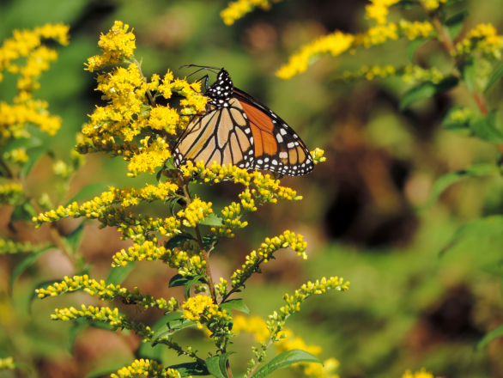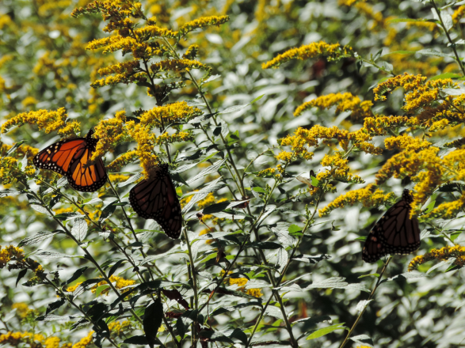

Limiting the phenotypic diversity of resource plants by reducing the sources of genetic material limits the number of (pollinator) species and individuals within those species which can utilize a particular plant species.

The further from wild stock a native plant becomes the less ecological utility it has because we naturally collect seeds from what appear to us to be the best looking plants within a defined time window. At the same time, plants which do well in cultivation may have lost the robustness and other traits necessary to survive in changing wild and semi-wild conditions.

Simply put:
No matter how successful a hybrid or cultivar appears to be it is an ecological failure. “The operation was a success, but the patient died.”

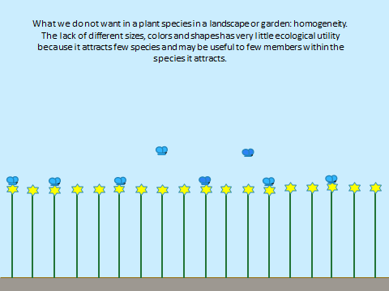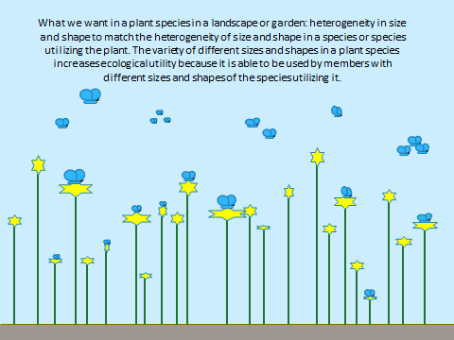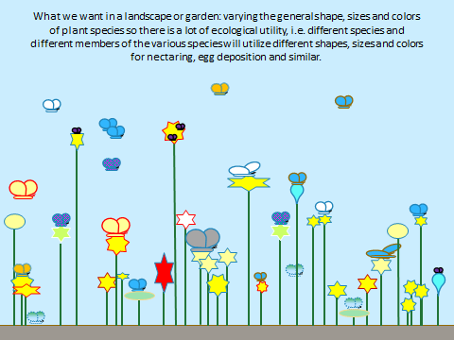

Linking landscapes is a limited short term vision. Whereas, the transformation of the present approach to agriculture and gardening is a long term philosophical and practical change necessary to provide healthy food locally and for the world while preserving the diverse native ecosystems which support our agriculture.

The integration of native organisms at all trophic levels into ecologically sound landscapes will provide the necessary ecosystem services to enhance not only food production but other aspects of a healthy environment such breathable air, drinkable water, open space and aesthetic landscapes. In the process, dependence on agricultural and lawn chemicals will be eliminated as environmentally sound methods and practices of meeting the needs of all stakeholders will be used. This will involve radical changes in thought patterns and actions, but benefits will swiftly accrue to all stakeholders from the tiniest organisms to the largest.

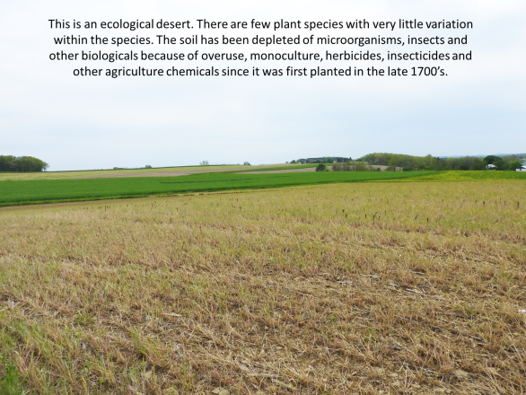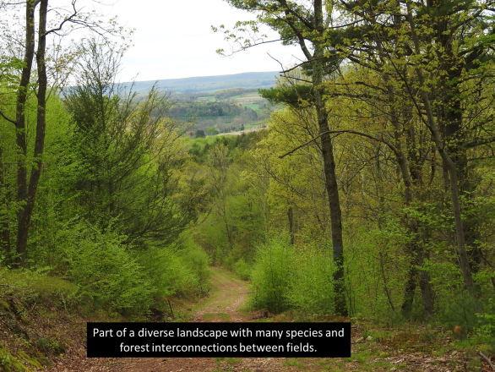

Simply put:

Agriculture at all scales instead of being ecologically destructive can function as an integrated part of natural systems through
understanding and working within the multiple levels and multiple dimensions of natural systems.

