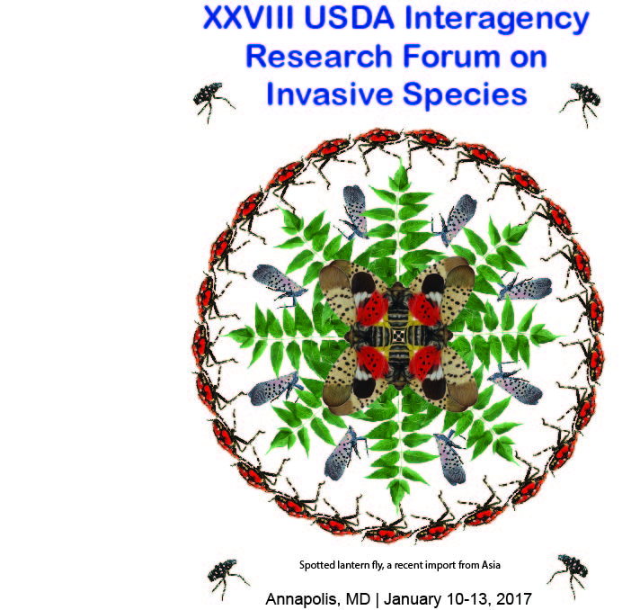

Tuesday Afternoon, January 10, 2017

Registration, Atrium
2:00-6:00 pm

Poster Session, Point Lookout
3:00-6:00 pm

Wednesday Morning, January 11, 2017
Opening Session
8:15 a.m. – 12:00 p.m.

Moderator
Therese Poland
USDA FS, NRS, Lansing, MI

8:15 a.m. Welcome - Michael McManus, Emeritus Scientist
USDA FS, NRS, Hamden, CT

8:30 a.m. Opening Keynote Presentations

The role of species interactions in forest invasions. Susan Kalisz, University of Tennessee, Knoxville, TN

9:15 a.m. Tamarix biocontrol: The importance of science in setting a path out of regulatory
dysfunction. Tom Dudley, University of California, Santa Barbara, CA

10:00 – 10:30 a.m. BREAK

Research Reports

10:30 a.m. – 12:00 p.m.

Moderator:
Therese Poland
USDA FS, NRS, Lansing, MI

10:30 a.m. Non-native forest pests in the US – impacts and policy options. Gary Lovett, Cary
Institute of Ecosystem Studies, Millbrook, NY

11:00 a.m. Informing efficient strategies to reduce pest risk from live plant imports. Rebecca
Epanchin-Niell, Resources for the Future, Washington, DC

11:30 a.m. Might climate change lower invasion risk? David Gray, Natural Resources Canada,
Fredericton, New Brunswick, Canada

11:50 a.m. – 1:00 p.m. LUNCH

Wednesday Afternoon, January 11, 2017

Northeast Biocontrol Regional Project (NE-1332): Honoring 27 years of Leadership by Dick Reardon in Research and Implementation of Biological Control of Forest Pests

1:00 – 3:00 p.m.

Moderator:
Scott M. Salom
Virginia Tech, Blacksburg, VA

1:00 p.m. Introduction

1:15 p.m. Biological control of houndstongue (Cynoglossum officinale) in the United States. Mark
Schwazländer, University of Idaho, Moscow, ID

1:30 p.m. Outrunning the invasive species treadmill: Integrating biological control and other
management techniques to restore invaded sites. Ellen Lake and Judy Hough-Goldstein,
University of Delaware, Newark, DE

1:45 p.m. Over 20 years of biological control for hemlock woolly adelgid: Not a very predictable
case study. Scott Salom, Virginia Tech, Blacksburg, V

2:00 p.m. Biological control of the winter moth in the Northeastern US. Joseph Elkinton, University of Massachusetts, Amherst, MA

2:15 p.m. The long term perspective of emerald ash borer biocontrol: Can introduced natural
enemies protect North American ash in the aftermath forests of invasion?, Jian Duan,
USDA ARS, Newark, DE

2:30 p.m. Native Sirex-Amylostereum-Deladenus meet invasive Sirex noctilio. Ann Hajek, Cornell
University, Ithaca, NY

2:45 p.m. A decade of using Verticillium nonalfalfae as a biocontrol of the invasive Ailanthus
altissimus in the eastern US. Matt Kasson, West Virginia University, Morgantown, WV

3:00-3:30 p.m. BREAK

Wednesday Afternoon, January 11, 2017
Research Reports
3:30 – 4:50 p.m.

Moderator
Noel Schneeberger
USDA FS, FHP, Newtown Square, PA

3:30 p.m. Range expansion of Southern Pine Beetle in the Northeast. Carissa Aoki, Dartmouth
College, Hanover, NH

3:50 p.m. Parasitism of the black oak gall wasp on Cape Cod and Long Island. Monica Davis,
University of Massachusetts, Amherst, MA

4:10 p.m. The impact of hybridization between native and non-native species on forest insect
invasions. Nathan Havill, USDA Forest Service, Hamden, CT

4:30 p.m. Combining lures for enhanced surveillance trapping of key forest insects. Eckehard
Brockerhoff. Scion, New Zealand Forest Research Institute, Christchurch, NZ

4:50 – 6:00 p.m. POSTER SESSION

6:00-8:00 p.m. MIXER

Thursday Morning, January 12, 2017
8:00-10:00 a.m.

Forest Phytophthora: They get around.
Organized by IUFRO Working Party 7.02.09, Phytophthoras in Forests and Natural Ecosystems

Moderator:
Paul Tooley
USDA ARS, Fort Detrick, MD

8:00 a.m. Phytophthora in wildlands. Everett Hansen, Oregon State University, Portland, OR

8:30 a.m. Plant disease predictions for invasive soilborne Phytophthora species are consistent
with host ecology and with genus-level co-evolutionary history. Laura Sims and Matteo Garbelotto, University of California, Berkeley, CA

9:00 a.m. Phytophthora foliar diseases on conifers: Phytphthora pluvialis in New Zealand and the
USA. Rebecca Ganley, Scion, Rotorua, NZ

9:30 a.m. Tackling emerging forest Phytphthoras in the UK: Mitigating risk of new introductions
and managing diseased landscapes for the future. Sarah Green, UK Forest Research,
Midlothian, UK

10:00-10:30 a.m. BREAK

Thursday Morning, January 12, 2017
10:30 a.m. – 12:00 p.m.

Invasive Organisms in Native Ecosystems: Effects on Structure and Function

Moderator:
Vince D’Amico
USDA FS, NRS, Newark, DE

10:30 a.m. Does multiflora rose invasion amplify tick-borne disease risk? Solny
Adalsteinsson. Washington University in St. Louis, St. Louis, MO

10:50 a.m. Invasive plants in the understory and effects on soil nutrient cycling. Tara Trammel,
University of Delaware, Newark, DE

11:10 a.m. Response of ground-dwelling arthropods to temporal patterns of ash mortality caused
by the emerald ash borer. Kayla Perry, The Ohio State University, Columbus, OH
11:30 a.m. Interaction diversity: The best measure of invasive species impacts. Doug Tallamy,
University of Delaware, Newark, DE

12:00 – 1:00 p.m. LUNCH

Thursday Afternoon, January 12, 2017

1:00 – 3:00 p.m.

Update on the Response to Spotted Lanternfly and Supporting Research in Pennsylvania

Moderator:
Sven-Erik Spichiger
PA Department of Agriculture, Harrisburg, PA

1:00 p.m. Update on spotted lantern fly program in Pennsylvania. Sven-Erik Spichiger,
Pennsylvania Department of Agriculture, Harrisburg, PA

1:15 p.m. DNA-based investigations of the spotted lanternfly. Julie Urban, Pennsylvania State
University, State College, PA

1:30 p.m. Investigating the host range of the spotted lanternfly (Lycorma delicatula) in
southeastern Pennsylvania. Gregory P. Setliff, Dept. Biology, Kutztown University of Pennsylvania, Kutztown, PA

1:45 p.m. Spotted lanternfly and grapevines: Damage assessment and chemical control.
Erica Smyers, Pennsylvania State University, State College, PA

2:00 p.m. Kairomones and trap technology for the spotted lanternfly, Lycorma delicatula
(Hemiptera: Fulgoridae). Miriam Cooperband, USDA APHIS, Buzzards Bay, MA

2:15 p.m. Natural enemies of the spotted lanternfly in Asia and North America, Houping Liu,
Pennsylvania Department of Conservation and Natural Resources, Harrisburg, PA

2:30p.m Efficacy and longevity of dinotefuran bark sprays to control the spotted lanternfly.
Phil Lewis, USDA APHIS, Buzzards Bay, MA
2:45p.m. Semiochemicals and mating behavior of adult spotted lanternfly. Mike Domingue,
and Tom Baker, Pennsylvania State University, State College, PA

3:00 – 3:30 p.m. BREAK

Thursday Afternoon, January 12, 2017

3:30 – 5:10 p.m.

Research Reports

Moderator:
Chris MacQuarrie
Natural Resources Canada, Sault Ste. Marie
Ontario, Canada

3:30 p.m. The uncertainty about attitude certainty about non-native insect control. Walter
Kuentzel, University of Vermont, Burlington, VT

3:50 p.m. The new EU PREPSYS project: Working to understand and manage the risks of exotic
buprestid beetles. Hugh Evans, Alice Holt Research Station, Farnham, Surrey, UK

4:10 p.m. Advantages to broadly targeted exotic species surveys. Jim Labonte, Oregon
Department of Agriculture, Salem, OR

4:30 p.m. Acoustic methods of invasive species detection in produce shipments. Hady Salloum,
Stevens Institute of Technology, Hoboken, NJ

4:50 p.m Assessment of systems approach for the phytosanitary treatment of wood infested with invasive wood borers. Chris MacQuarrie. Natural Resources Canada, Great Lakes
Forestry Centre, Sault Ste. Marie, Ontario, Canada

Friday Morning, January 13, 2017

8:00 a.m. – 11:30 p.m.

Research Reports

Moderator:

8:00a.m. Update on EPPO activities in forest quarantine. Andrei Orlinski, European and Mediterranean Plant Protection Organization, Paris, France

8:20 a.m. First Results of a multilure trapping program to detect exotic cerambycids at ports of entry in France. Alain Roques, INRA, Orleans, France

8:40 a.m. Evaluation of lure and trap design for monitoring the velvet longhorned beetle, Trichoferus campestris. Annie Ray, Xavier University, Cincinnati, OH

9:00 a.m. APHIS EAB national program update. Paul Chaloux, USDA APHIS, Riverdale, MD

9:20 a.m. Area wide pest management programs against emerald ash borer: Recent progress and challenges. Jian Duan, USDA ARS, Newark, DE

9:40 a.m. BREAK

10:00 a.m. Tracking the Entomophaga maimaiga Death Cloud. Ann Hajek, Cornell University, Ithaca, NY

10:20 a.m. Why is the gypsy moth the world’s most prolific defoliator? Andrew Liebhold, USDA Forest Service, Morgantown, WV

10:40 a.m. More than a number: Spatiotemporal drivers of variation in trap captured male gypsy moth wing morphology. Dylan Parry, Syracuse University, Syracuse, NY

11:00 a.m. Concluding Remarks. Michael McManus

