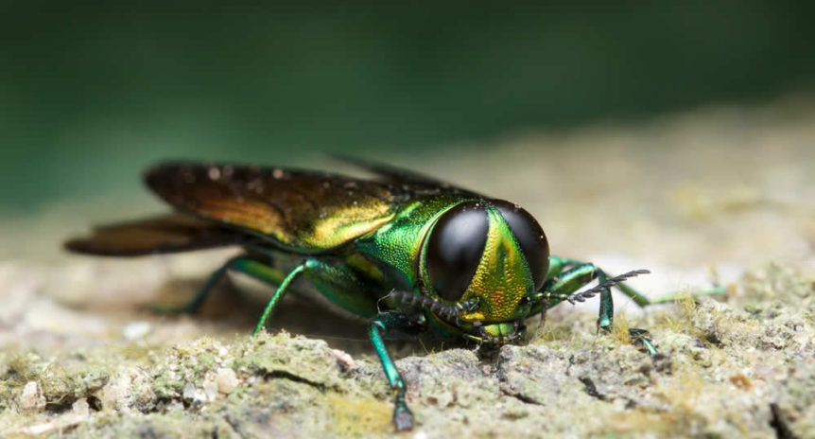*Photo Credit: Shutterstock*

**Emerald Ash Borer Workshop**

*An Integrated Approach to Managing the Invasive Emerald Ash Borer Using Biological Control and Systemic Insecticides to Protect North American Ash Resources*

**July 10, 2018 (8:00am to 2:30pm)**

**U.S. National Arboretum, Washington DC (Auditorium)**

3501 New York Ave., NE, Washington DC 20002; 202-245-2726

Sponsored by the U.S. National Arboretum and U.S. Forest Service

[**Registration is required.**](https://campscui.active.com/orgs/NationalArboretumUSDA?season=2431902&session=38849206) **Please register by June 30.**

**Registration fee is $10. Optional lunch $12 (You must pre-order lunch; pay at workshop).**

For more information on the program, contact Jil Swearingen at: jilswearingen (at) gmail.com

**Agenda**

8:00a Sign in/Refreshments. *Pay for lunch ($12 cash)  
**Morning Program**

9:00 *Welcome/Introduction*. Jil Swearingen & Dick Reardon

9:10 **Deb McCullough**. *Using What We’ve Learned to Manage Ash & EAB.*

10:00 **Roy van Driesche**. *Overview of Biocontrol for Insect Pests.*

10:30 **Jian Duan.**  *Biocontrol of EAB* - Progress and Challenges.

10:45 Break

11:00 **Houping Liu*.*** *Pennsylvania EAB update.*

11:15 **Colleen Kenny.** *Maryland EAB update.*

11:30 **Lori Chamberlin***. Virginia EAB update.*

11:45 **Trent Dicks***. Chemical Control of EAB Using Insecticide Injection.*

12:15 **Chris Carley**. *U.S. National Arboretum efforts.*

12:30 Lunch ($12/person) or BYO

**Field Event**

1:15 **Ben Slager***. EAB parasitoid rearing, field release permit and request.*

1:30 **Jian Duan*.*** *Field releases of EAB parastoids*

2:30 Program concludes

~~~~~~~~~~~~~~~~~~~~~~~~~

The Emerald Ash Borer (*Agrilus planipennis*) is one of our most serious invasive insect pests and has killed millions of ash trees from Michigan to Maryland. It continues to spread into the Southeast. However, all hope is not lost. Uninfected ash trees, resprouts, saplings and seedlings can be protected with help from biological and chemical control, providing opportunities for ash forest regeneration and restoration. This workshop will provide urban forest managers, park managers, land managers, landowners and others with the latest information on how to protect ash from EAB infestation using integrated pest management.

**Speakers**

**Chris Carley.** Chris is a Supervisory Horticulturist at the US National Arboretum. He manages half of the garden staff, including the IPM technician.

**Lori Chamberlin.** Lori is the Forest Health Manager at the Virginia Department of Forestry. VDOF's Forest Health Program surveys and monitors the state for major forest pests, pathogens, non-native invasive plants and other disturbances.

**Trent Dicks.** Trent is Arbojet’s Atlantic Regional Technical Manager with a geographic outreach area from Maine to North Carolina. He holds a Bachelor of Science Degree in Agri-Business Horticulture from Illinois State University, an Associate’s Degree in Applied Science and Horticulture He has over 20 years of experience in Landscape and Nursery sales and operations, managed a small garden center and operated a small nursery and landscape company in the Midwest.

**Roy van Driesche, PhD.** Roy is Professor of Entomology, University of Massachusetts, Amherst. He is an entomologist, with a specialization in biological control of invasive species (insects and plants), with current work all centered on the impact of these pests on natural communities, mostly forests. He is interested in the impacts of invasive species on natural communities and the process of using introduced natural enemies from their native ranges to lower their population densities on the landscape. His current activities are biological control of emerald ash borer (research) and public education concerning biological control in relation to invasive pests of wildlands.

**Jian Duan, PhD.**Jian is a Research Entomologist at the U.S. Department of Agriculture, Agricultural Research Service, Beneficial Insects Introduction Research Unit in Newark, Delaware. He has been leading the research program for biological control of invasive wood-boring insects such as emerald ash borer and Asian longhorned beetle since 2008. Jian J. Duan got his Ph.D. in Entomology from University of Massachusetts at Amherst in 1994.

**Colleen Kenny.** Colleen is Forest Health Planner for the Maryland DNR Forest Service where she coordinates invasive species management programs with state and local governments, including Emerald Ash Borer planning and response.

**Houping Liu, PhD.** Houping is the Forest Entomologist at the Pennsylvania Department of Conservation and Natural Resources (DCNR) since 2008. Since receiving his PhD in Entomology from the University of Vermont in 2001, he worked as a Research Scientist at Michigan State University on biological control of Asian longhorned beetle and emerald ash borer.  In his current role, he coordinates survey, detection, and management activities for exotic invasive species as well as native forest pests in Pennsylvania, including emerald ash borer, hemlock woolly adelgid, *Sirex* wood wasp, Asian longhorned beetle, forest tent caterpillar, and gypsy moth.

**Deborah G. McCullough, PhD**. Deb is Professor with a joint appointment in the Dept. of Entomology and Dept. of Forestry at Michigan State University, Ann Arbor. She has an M.S. in Forestry from Northern Arizona University, and a PhD in Entomology from University of Minnesota. Her responsibilities include research, extension and teaching. Deb’s research focuses on the ecology, impacts and management of invasive forest insects, including emerald ash borer, beech bark disease, and most recently, hemlock woolly adelgid. She works with forest managers, regulatory officials, arborists and landowners to identify damaging forest insect populations and to develop sustainable management strategies to protect forest health. Deb has published over 100 papers on forest insect ecology and management in scientific journals, and more than 200 extension bulletins and articles. She is a member of the national Forest Research Advisory Committee, the Science Advisory Board of American Forests, and serves on the Michigan Forest Invasive Species Committee.

**Benjamin Slager.** Ben is the Supervisory Entomologist directing the Emerald Ash Borer (EAB) Biological Control Rearing Facility in Brighton, MI. He joined the EAB program in 2015 and has worked to facilitate expanding the biological control release footprint, increase public awareness of EAB biological control, and communicate technical information across national working groups. Ben collaborates with USDA colleagues to further the current understanding of the biology and interactions of the EAB and its associated parasitoids.