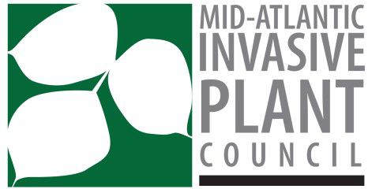
Dear Supporter:

As you may know, the Mid-Atlantic Invasive Plant Council (MAIPC) holds a biennial conference where we bring leading practitioners, academics, and advocates from government, business, non-profit environmental groups, and academia together for a two-day symposium. We are writing to ask for your support for this year’s conference. The conference will be held on August 5 & 6, 2019 at Juniata College in Huntington, Pennsylvania. The conference’s speakers and agenda can be accessed here: http://www.maipc.org/2019-conference/. Our keynote this year is Dr. Vanessa Lopez, U.S. Forest Service, Invasive Plants National Program Manager.

MAIPC’s mission is to address the problem of invasive plants and their threats to the Mid-Atlantic region's economy, environment, and human health by providing leadership, facilitating information development and exchange, and coordinating regional efforts.

Please consider becoming a sponsor of our conference. Sponsorship is a wonderful way to promote your organization to the larger invasive plant and ecological restoration community. It also helps us keep the event affordable to a wider audience. Our standard sponsorship levels and special sponsorship opportunities are listed in the tables below:

SUPPORTER | NOT-FOR-PROFIT | $300 | - One registration  - Exhibit table  - Listed as sponsor on website and in conference materials
 | BUSINESS | $400
PROGRAM | BUSINESS | $500 | - One registration  - Exhibit table  - Prominently listed as “Champion” on website and in conference materials  - Opportunity to provide promotional insert in conference folder  - Opportunity to provide marketing slides to be run during conference breaks
CHAMPION | BUSINESS | $700 | - Two registrations  - Exhibit table  - Name included on sponsor signage at event  - Prominently listed on website and in conference materials  - Opportunity to provide promotional insert in conference folder  - Opportunity to provide marketing slides to be run during conference breaks

Special sponsorship opportunities:

LUNCH  (2 available) | BUSINESS | $600 | - Same as Program sponsorship  - Recognition at food areas  - Recognition on sponsor signage at event
PLENARY SESSION  (3 available) | BUSINESS | $800 | - Same as Champion sponsor  - Recognition on sponsor signage at event  - Verbal recognition at the beginning of session
PANEL SESSION  (2 available) | BUSINESS | $800 | - Same as Champion sponsor  - Recognition on sponsor signage at event  - Verbal recognition at the beginning of session

Please contact Andrew Rohrbaugh (Mid-Atlantic Invasive Plant Council Sponsorship Committee) to arrange your sponsorship: anrohrbaug@pa.gov

Thank you in advance for your sponsorship,

Norris Muth
President, Mid-Atlantic Invasive Plant Council

