***Claytonia***

**Newsletter of the John Clayton Chapter, Virginia Native Plant Society**

Volume 37, Number 1 January–February 2021 www.claytonvnps.org

|  |  |
| --- | --- |
| January–February 2021  **From Out in Left Field**  ***Kathi Mestayer***  **Ailanthus: Tree of Heck—Looking for another plant to hate, and kill?**  In August, I got an email from the Blue Ridge PRISM (Partnership for Regional Invasive Species Management, [blueridgeprism.org](http://blueridgeprism.org)) announcing that Ailanthus, or tree of “heaven,” has been added to Virginia’s Noxious Weeds List, along with Porcelainberry, Oriental bittersweet, Mile-a-minute, Hydrilla, and Incised fumewort.  **What does it mean to be on that list? Here’s a quote from PRISM’s website, under “News”:**  “Once a plant is on this list it may not be sold at your local nursery nor be moved across State lines (except where a permit has been approved for use such as for exper- imental research). You are also not allowed to transport it anywhere within Virginia. Any person who fails to comply with this law is guilty of a Class 1 misdemeanor.”  Okay! Bad plant! We already knew that, but it’s good news that it’s been officially designated. As if that isn’t bad enough, it has come to the attention of the scientific community that “Spotted Lanternfly adults primarily feed on branches and trunks of tree-of-heaven and willow.” (Also quoted from PRISM website.)  **How to identify it?**  On my frequent walks, I had started noticing some ailanthus trees at the edge of my neighborhood. As expected, they were making my teeth gnash every time I spotted them. They were smallish, and looked like a new outbreak, which always gets me going...if you can stop it early, it’s a little more...doable).  The first step was to make sure I knew what I was looking at. I checked the PRISM website, again (the ailanthus Fact Sheet is titled “Furiously Aggressive Invasive”) and saw photos of the ailanthus leaves, alongside trees that look similar. Finally, I found the best way for me to i.d. the small trees...pick off a leaf, crush it, and smell it, for the “rancid peanut-butter odor of its crushed leaves and stems.” Wow. Very stinky! That, along with the un-toothed edges and weird little blobby shapes at the base of the leaflets made it clear that they were, indeed, ailanthus (ailanthi?).  **How to kill it?**  At the end of August, I got an email from PRISM that said: “Alert—Treat Ailan- thus (Tree of Heaven) Now.” Okay, perfect timing! Apparently, the best time to kill them is fall, before the leaves fall off.  The Fact Sheet recommended, for trees with trunks less than 6 inches in diameter, basal bark treatment with herbicide, applied in a complete circle, onto the lowest 12 inches of the trunk. No hacking the bark at this early growth stage, but for larger trees, they suggest hacking around the trunk, leaving about 2 inches between the cuts, to move the herbicide into the roots more effectively, and to prevent the tree from sending up suckers. Interesting. | 11 |

January–February 2021

The Virginia Department of Forestry recom- mends using Triclopyr ester at 20–25%, and the PRISM fact sheet said to dilute it in mineral oil. So, I purchased, online, Pathfinder 2, which is pre-mixed, so I didn’t have to find the right oil and...whatever. I applied it around the bark of the young trees with a sponge applicator (to avoid having to spray it) in October, and they are looking pretty...dead...right now.

**What next?**

Of course, I’m keeping my eye on them, in case they come back from the dead. And, FYI, I have a LOT of the Pathfinder 2 left over; I had to buy a very large amount because it was the only way it was available. So, if you have some ailanthus you want to kill, let me know. There’s plenty to share.

And don’t forget english ivy! Now’s the time to cut-and-dab the vines, with a much-lower likelihood of ticks, chiggers, and the like. What could be more fun?

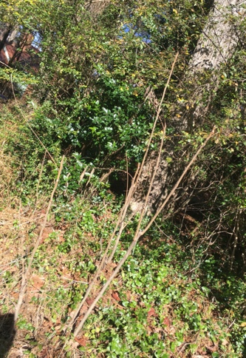

Dead ailanthus trees, still under surveillance.

