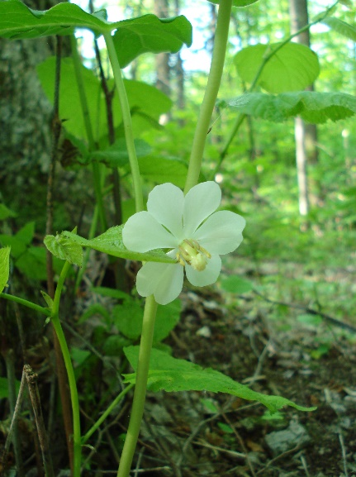
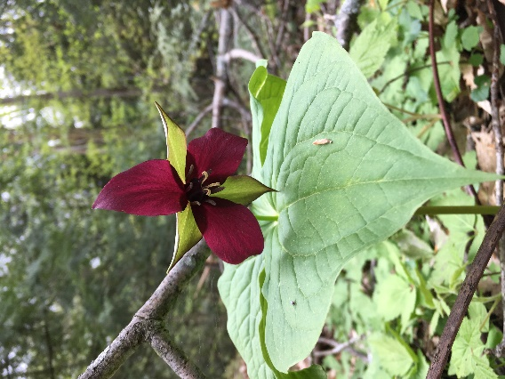
PA Native Species Day – Thursday, May 18, 2023

“Go Native” on Thursday, May 18, 2023 when Pennsylvania will observe the 2nd Annual Native Species Day. Every region of Pennsylvania has unique and diverse trees, plants, insects, fish, birds and mammals, so we have a lot to celebrate. Pennsylvania is home to many native species that add value to our everyday lives. What can you do to help celebrate?
- Learn about what species are native to PA and why they are important.
- Plant native species in your yard, garden and forest.
- Help reduce the spread of invasive species.
- Attend one of many Native Species Day events offered by participating organizations around the state: Find a list of activities here: www.NativeSpeciesDay.pa.gov

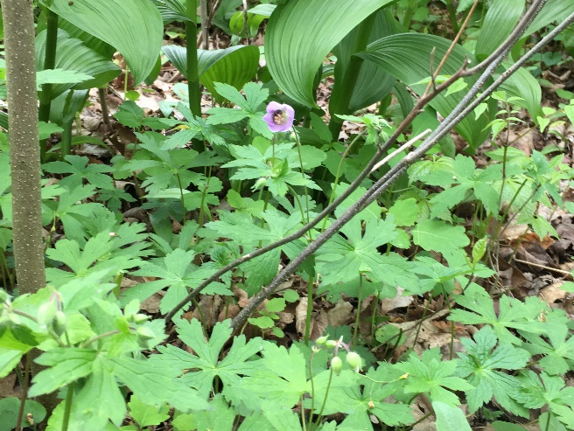
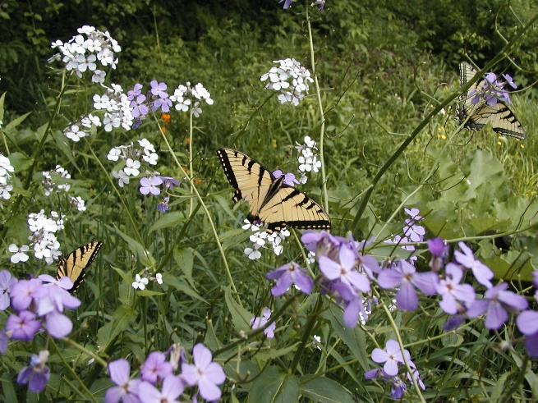
Help celebrate Pennsylvania’s native and natural resources!

